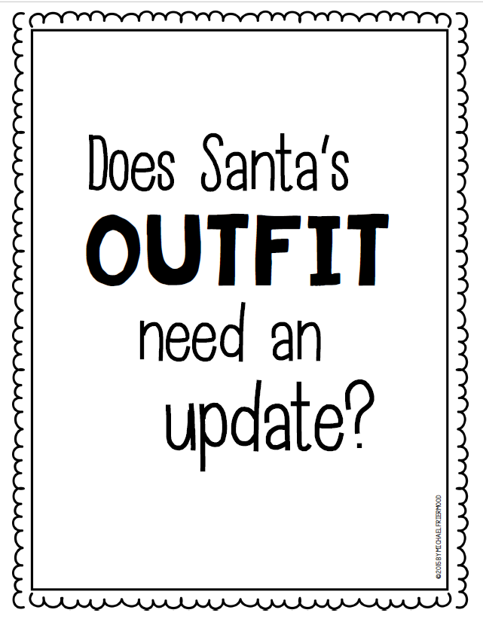

Does Santa need a new suit?
- Read the fact sheet and decide on a position.
- Fill out the opinion writer planner, gluing 2 facts from the fact sheet to use as support of your opinion within your essay.
- Write your essay. Use your own reasons as well as the evidence provided to prove your claim. This should be at least 3 paragraphs.

